
Data Security Envisioning Workshop
02-Module Delivery Guide-SharePoint
v8.5 - January 2026

Contents
Disclaimer 3
Version history 4
We look forward to your feedback! 4
1 Introduction 5
1.1 Objectives 5
1.2 Delivery guidance 5
1.3 Scoping 6
1.4 Estimated partner effort 6
1.5 Tools and services used 6
1.5.1 Microsoft Purview eDiscovery 6
2 Activity details 8
2.1 Step 1 - Kick-off meeting 8
2.2 Step 2 - Acquire and assign licenses 8
2.3 Step 3 - Setup and configuration 8
2.3.1 eDiscovery Search – Stale Data 9
2.3.2 eDiscovery Search – Out-of-box Sensitive Info Types 12
2.3.3 eDiscovery Search - Custom Sensitive Info Types 14
2.4 Step 4 - Analyze the findings 17
2.4.1 Prepare for analysis – eDiscovery Search 18
2.4.2 Analyze results - eDiscovery Search 20
2.5 Step 6 - Decommission 23

Disclaimer
The Data Security Envisioning Workshop provides a summary of an organization’s data protection and compliance stature and recommendations to improve data protection and compliance.
The information, results, and scoring provided through the Data Security Envisioning Workshop are recommendations and provided for general informational purposes only. They do not constitute legal advice, certifications, or guarantees regarding regulatory compliance; it is up to each organization to evaluate the effectiveness of these recommendations in their respective regulatory environment prior to implementation. Organizations should consult with their own legal professionals to determine how standards or regulations apply to their organization and how to best ensure compliance.
We hope the Data Security Envisioning Workshop helps identify technologies and additional steps that organizations can implement to simplify their compliance efforts.
MICROSOFT MAKES NO WARRANTIES, EXPRESS, IMPLIED, OR STATUTORY, AS TO THE INFORMATION IN THIS Data Security Envisioning Workshop. Microsoft disclaims any conditions, express or implied, or other terms that use of the Microsoft products or services will ensure the organization’s compliance with regulations or standards. This Data Security Envisioning Workshop toolkit is provided “as-is.” Information and recommendations expressed in the Data Security Envisioning Workshop toolkit may change without notice.
The Data Security Envisioning Workshop toolkit does not provide the user with any legal rights to any intellectual property in any Microsoft product or service. Use of the tool is for internal, reference purposes only; however, Microsoft partners may distribute the Data Security Envisioning Workshop toolkit to their customers for such customers’ internal, reference purposes only. Any distribution of the Data Security Envisioning Workshop toolkit by a Microsoft partner to its customers must include terms consistent with those set forth in this disclaimer.
© 2026 Microsoft. All rights reserved.

Version history
Version | Author | Changes | Date
4.0 | François van Hemert | First standalone version to align with new narrative, rebranding, updates to guidance and organized around data repositories. | June 2021
4.1 | François van Hemert | Update illustration for Compliance Manager Premium Assessments | October 2021
4.2 | François van Hemert | Purview branding update, step-by-step guidance update to align with changes M365 | July 2022
4.2.2 | François van Hemert | Update to align with current product features and functionality (evergreen) | January 2023
6.0 | François van Hemert | Workshop merge, align with FY24 solution play, focus on Data Security. | August 2023
6.5 | François van Hemert | Update step guidance, align with FY25 solution play. | July 2024
6.6 | François van Hemert | Update to align with the new Microsoft Purview Portal | October 2024
7.0 | François van Hemert | Updated for additional module on Generative AI | January 2025
7.1 | François van Hemert | Updated Content Search guidance to align with new eDiscovery experience | May 2025
8.0 | François van Hemert | Update to align with current product features and functionality (evergreen), update name, update branding. | July 2025
8.5 | François van Hemert | Update to align with current product features and functionality (evergreen) | January 2026


We look forward to your feedback!
Thank you for your continued trust and partnership. The resources within this toolkit will be iteratively improved upon based on product releases as well as direct feedback from delivered engagements. We encourage you to provide feedback to help us improve our products and toolkits.
Please share your feedback and questions via our Engagement feedback form that can be found at: https://aka.ms/SCIEngagementsFeedback.

Introduction
This document contains delivery guidance that will extend the Automated Discovery Process to scan SharePoint Online data repositories for content that may impose privacy and regulatory risks to the organization.
The outcome and findings of this activity will be merged into the overall findings and recommendations that will be presented at the end of the Data Security Envisioning Workshop.

Objectives
The objectives for this activity are:
- Discover data security risks in SharePoint Online repositories.
Gain visibility into existing, and sometimes hidden, data security risks that might exist in the customer’s organizational data stored in the SharePoint Online repositories.
- Understand how to mitigate the identified data security risks.
Help customers better understand, prioritize, and mitigate these data security risks across on-premises data repositories.
- Provide recommendations and define next steps.
Recommendations and next steps based on the findings from this activity will be rolled up into the overall Data Security Envisioning Workshop close-out presentation.

Delivery guidance
This document is an integral part of the overall delivery guidance for the Data Security Envisioning Workshop. When delivering the Data Security Check, follow the guidance provided in the 00-Master Delivery Guide and when instructed, engage in the supplemental activities outlined in this guide.
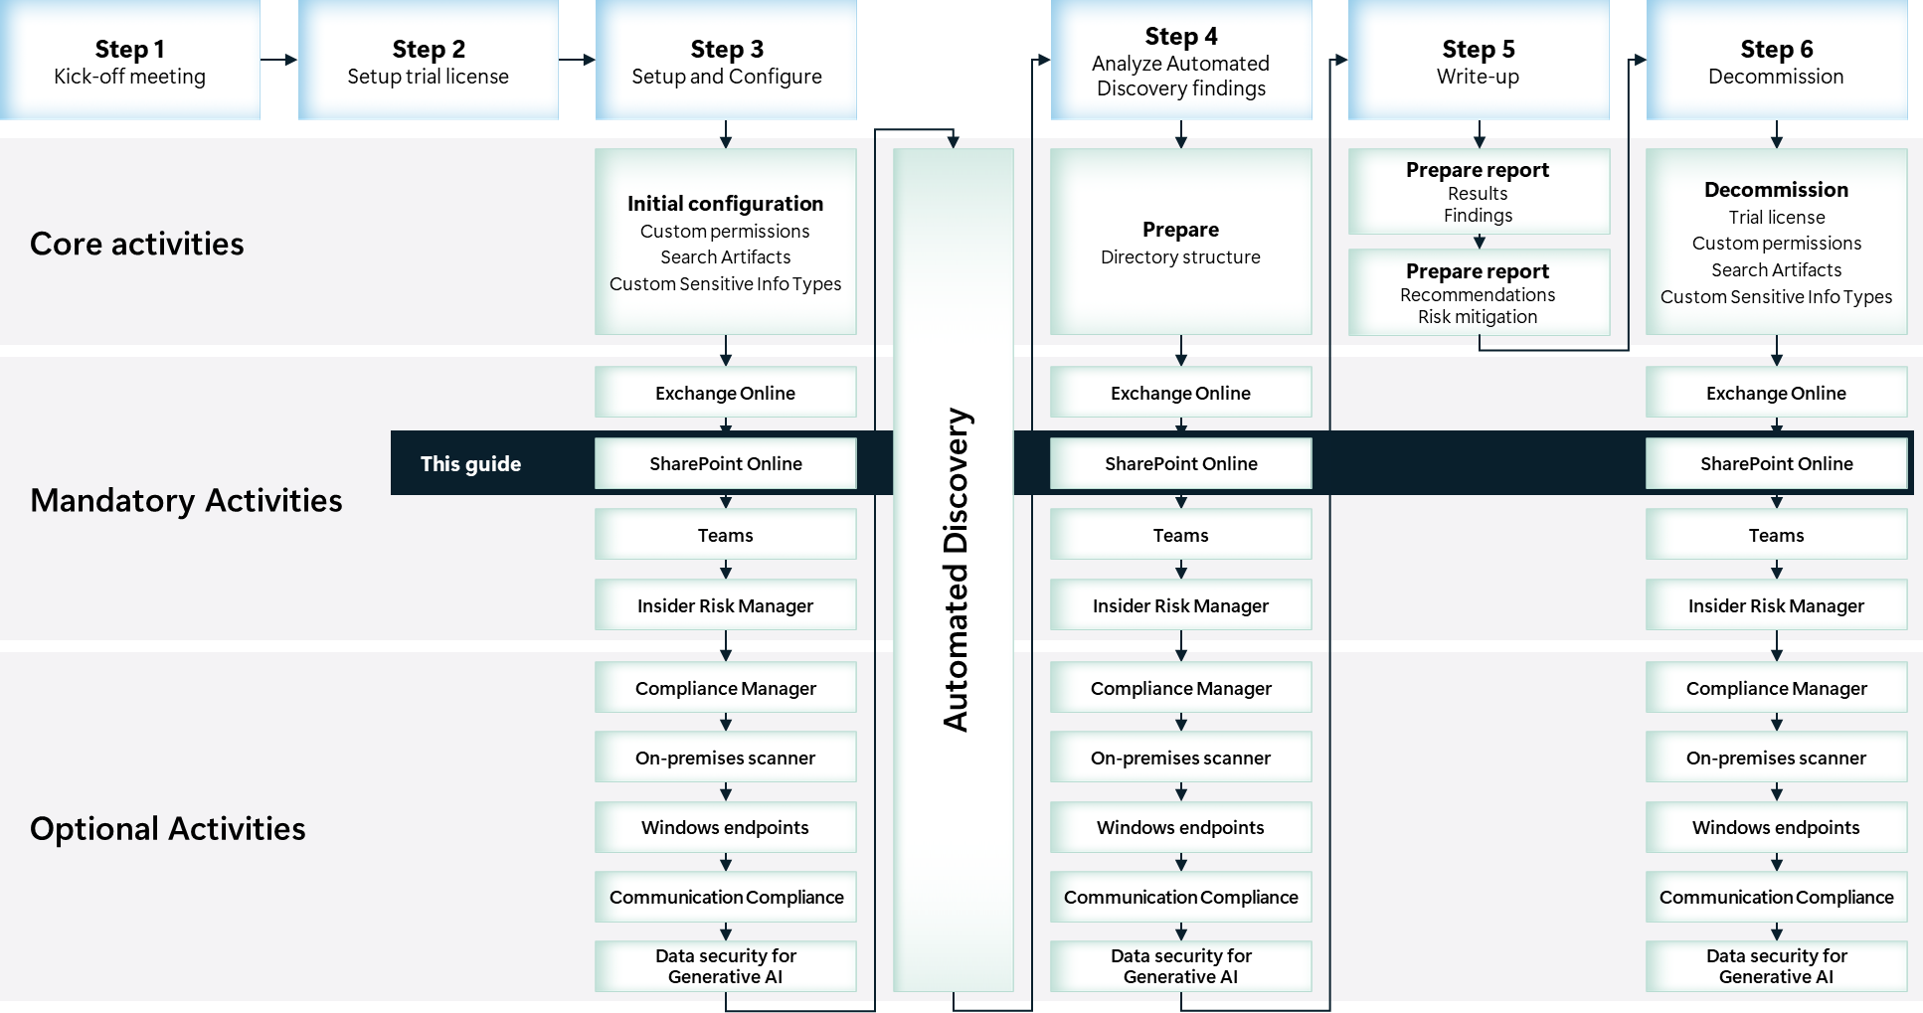

Scoping

In scope
The scope for this activity includes:
- Configure Microsoft Purview eDiscovery.
- Gain visibility into hidden privacy and regulatory risks in SharePoint Online repositories in use by the customer.

Estimated partner effort
The table below provides a high-level estimate of the partner effort for the activities described in this guide. The numbers provided are to be considered indicative and can change as a result of customization of the delivery schedule and the individual activities.
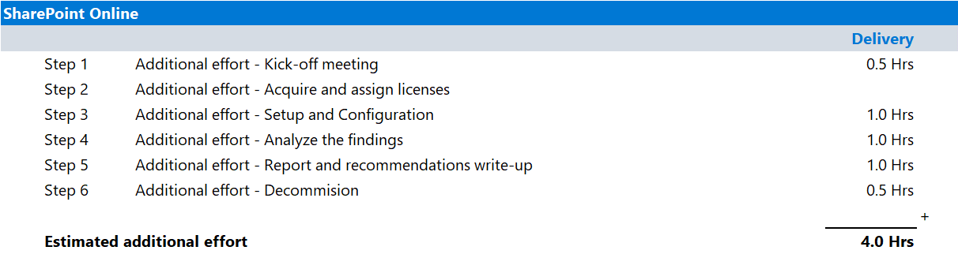

Tools and services used
- The Data Security Check Automated Discovery process leverages Microsoft Purview eDiscovery to discover and report on data security risks in SharePoint Online.

Microsoft Purview eDiscovery

Overview
Microsoft Purview eDiscovery can be used to quickly find emails in Exchange mailboxes, documents in SharePoint sites and OneDrive locations, and saved instant messaging conversations.
Microsoft Purview eDiscovery includes the following search capabilities that the Data Security Check will leverage:
- Keyword and condition-based queries, use Boolean operators, wildcards, and property filters.
- Scoping by user, group, or location, target specific custodians or content locations.
- Time range filtering, narrow results to specific date ranges.
- Preview and export, review search results before exporting them for legal or compliance review.

Product information
For detailed information about eDiscovery, refer to:
- Get started with eDiscovery.
- Upcoming changes to Microsoft Purview eDiscovery

Functionality used by the Data Security Check
The Data Security Check will leverage eDiscovery for the discovery of data security risks in:
- SharePoint Online sites
- OneDrive for Business accounts

Activity details

Step 1 - Kick-off meeting

Guidance
Follow the guidance for the Kick-off meeting provided in the 00-Master Delivery Guide and add the following discussion topics to the meeting:
- SharePoint Online data repositories, discuss what types of data are stored in the online repository.
- The tools used by the Automated Discovery process: Microsoft Purview eDiscovery.
- The types of data security risks that can be identified by the Automated Discovery for SharePoint Online.
The 40-Pre-engagement and Kickoff deck contains optional slides with speaker notes that can be used to facilitate the discussion.

Supporting materials
- <40-Pre-engagement and Kickoff deck>
Note
The <40-Pre-engagement and Kickoff deck> is used during the Pre-engagement meeting and the Kick-off meeting. Instructions on how to update the slides are included as hidden slides in the deck.

Pre-requisites
The activities and guidance described in this step complement Step 1 - Kick-off meeting as described in the 00-Master Delivery Guide. The activities should be merged and delivered as one.

Next step
- Return to the <00-Master Delivery Guide> and continue the guidance provided in Step 1 - Kick-off meeting.

Step 2 - Acquire and assign licenses
The required product licenses for this activity are included in the overall Data Security Check trial license that was deployed in Step 2 - Acquire and assign licenses described in 00-Master Delivery Guide.

Step 3 - Setup and configuration
The Automated Discovery process leverages eDiscovery to search for privacy and regulatory risks in SharePoint Online data repositories.
The following paragraphs provide step-by-step instructions to configure eDiscovery to search for Out-of-box Sensitive Info Types, Custom Sensitive Info Types, and stale data in SharePoint Online data repositories. Multiple policies will be configured and, where applicable, Sensitive Info Types created previously will be re-used.

Pre-requisites
Prior to starting the activities in this step, the following mandatory Data Security Check activities as described in <00-Master Delivery Guide> should be completed:
- Step 1 - Kick-off meeting
- Step 2 - Acquire and assign licenses
- Step 3 - Setup and configuration

Important
eDiscovery Search as utilized by the Data Security Check depends on Sensitive Info Types to identify data security risks. Before starting this activity, the instructions outlined in Step 3 - Setup and configuration in the 00-Master Delivery Guide should be completed successfully. (i.e., all customer specific sensitive information types configured and available).

eDiscovery Search – Stale Data

Guidance
The Automated Discovery process leverages Microsoft Purview eDiscovery for the discovery of stale data. A new search will be configured and targeted to specific data locations and types in the customer’s tenant. In this section we will describe the steps to create and configure an eDiscovery Search for stale data.

Objective(s)
- Create a eDiscovery Search to be used by the Automated Discovery process to identify stale data in SharePoint Online.

Automated Discovery target locations
- SharePoint Online - existing data prior to start of the Data Security Check
- SharePoint Online - new data since the start of the Data Security Check
- OneDrive for Business - existing data prior to start of the Data Security Check
- OneDrive for Business - new data since the start of the Data Security Check
- SharePoint Online sites associated to Teams - existing data prior to start of the Data Security Check
- SharePoint Online sites associated to Teams - new data since the start of the Data Security Check

Background reading
For more information searching data in Microsoft SharePoint Online refer to:
- Keyword queries and search conditions for eDiscovery
- Searchable site properties
- Overview of crawled and managed properties in SharePoint Server
- Keyword Query Language (KQL) syntax reference
- Get started with eDiscovery.
- Upcoming changes to Microsoft Purview eDiscovery

Instructions – create an eDiscovery Search
- Browse to the Microsoft Purview portal at https://purview.microsoft.com/ and log in with Tenant Admin credentials or a user account that is a member of your Data Security Check team and has been assigned the appropriate permissions.
- In the navigation bar on the left side, click on Solutions .
- In the Solutions navigator, click on eDiscovery.
- On the eDiscovery solution card, click on Cases.
- On the Cases page, click on the previously created case DataSecurityCheck-Case.
- On the DataSecurityCheck-Case, on the Searches tab, click Create a search.
- Name your new eDiscovery Search DataSecurityCheck-CS-StaleData-SharePoint and provide a meaningful Description.
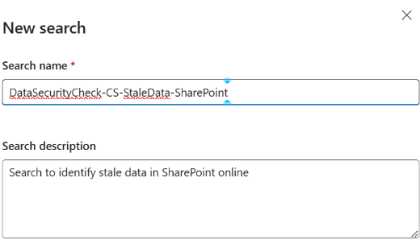
- Click Create.
- On the DataSecurityCheck-CS-StaleData-SharePoint page, on the Query tab, on the Data sources card, click on Add tenant-wide sources.
- On the Manage sources page, select Sites and deselect Mailboxes.
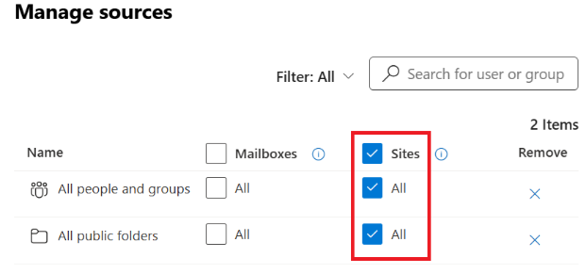
- Click Save.

Note
By enabling SharePoint sites, eDiscovery Search will also search for sensitive data related to OneDrive accounts, Microsoft 365 group sites, Teams sites, and Yammer Networks.

- On the DataSecurityCheck-CS-StaleData-SharePoint page, on the Condition builder tab, click on +Add conditions.
- Click Show more.
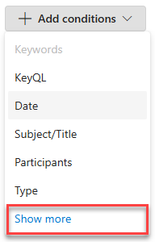
- On the Choose which conditions to add fly-out, below Common conditions, select Date and Content kind.
- Below Conditions for SharePoint and OneDrive sites, select File type.
- Click on Apply.
- On the Condition builder tab, next to Enter a keyword or …, click on the Trashcan icon () to delete the Keywords condition.
- Next to Date, verify Before is selected and enter a date that meets the criteria defined during the Pre-engagement meeting or Kick-off meeting.

Note
If stale data is defined a “Older than one year”, calculate the date to use by subtracting one year from today. Enter the date for the Condition.

- Next to Content Kind, verify Contains any of is selected and enter Document in the input box.
- Next to Filetype, select Equals none of and enter aspx in the input box.
- On the DataSecurityCheck-CS-StaleData-SharePoint page, click on Run query.
- On the Choose search results flyout, below Statistics, select Include categories and Include query keywords report.
- Click on Run Query.

Note
The eDiscovery Search will run after creation. The time it takes to complete the search depends on the amount of data, the complexity of the search query, and the location where the data is stored. Refer to Limits in eDiscovery for details.

eDiscovery Search – Out-of-box Sensitive Info Types

Guidance
The Automated Discovery process leverages Microsoft Purview eDiscovery for the discovery of Out-of-box Sensitive Info Types such as credit card numbers and passport numbers. A new search will be configured and targeted to specific data locations and types in the customer’s tenant. In this section we will provide a sample configuration that discovers credit card numbers and social security numbers in data that is stored in SharePoint Online and OneDrive for Business. The sample search configuration should be updated to match customer requirements by adding or replacing Sensitive Info Types. An overview of all available Sensitive Info Types can be found at Sensitive information type entity definitions.

Objective(s)
- Create an eDiscovery Search to be used by the Automated Discovery to identify credit card numbers data stored in SharePoint Online (SharePoint Online sites, OneDrive for Business accounts, Teams files, and Microsoft 365 Group sites).

Automated Discovery target locations
- SharePoint Online - existing data prior to start of the Data Security Check
- SharePoint Online - new data since the start of the Data Security Check
- OneDrive for Business - existing data prior to start of the Data Security Check
- OneDrive for Business - new data since the start of the Data Security Check
- Teams sites - existing data prior to start of the Data Security Check
- Teams sites - new data since the start of the Data Security Check

Background reading
For more information refer to:
- Sensitive information type entity definitions
- Keyword queries and search conditions for eDiscovery
- Keyword Query Language (KQL) syntax reference
- Get started with eDiscovery.
- Upcoming changes to Microsoft Purview eDiscovery

Instructions – Create a new eDiscovery Search.
- Browse to the Microsoft Purview portal at https://purview.microsoft.com/ and log in with Tenant Admin credentials or a user account that is a member of your Data Security Check team and has been assigned the appropriate permissions.
- In the navigation bar on the left side, click on Solutions .
- In the Solutions navigator, click on eDiscovery.
- On the eDiscovery solution card, click on Cases.
- On the Cases page, click on the previously created case DataSecurityCheck-Case.
- On the DataSecurityCheck-Case, on the Searches tab, click Create a search.
- Name your new eDiscovery Search DataSecurityCheck-CS-OutOfBox-SharePoint and provide a meaningful Description.
- Click Create.
- On the DataSecurityCheck-CS-OutOfBox-SharePoint page, on the Query tab, on the Data sources,card, click on Add tenant-wide sources.
- On the Manage sources page, select Sites and deselect Mailboxes.

- Click Save.

Note
By enabling SharePoint sites, eDiscovery Search will also search for sensitive data related to OneDrive for Business accounts, Microsoft 365 Group sites, Teams sites, and Viva Engage (Yammer) Networks.

- On the DataSecurityCheck-CS-OutOfBox-SharePoint page, on the Condition builder tab, click on +Add conditions.
- Click Show more.

- On the Choose which conditions to add fly-out, below Conditions for SharePoint and OneDrive sites, select Sensitive Type.
- Click on Apply.
- On the Condition builder tab, next to Enter a keyword or …, click on the Trashcan icon () to delete the Keywords condition.
- Next to Sensitive, verify Equal is selected and enter Credit Card Number, leave the Min, Max, and Confidence input boxes blank.
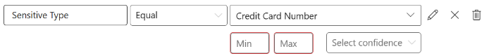
Add additional Sensitive Info Types
The eDiscovery Search can be extended to search for additional Sensitive Info Types as defined by the customer. Repeat the steps below for each Sensitive Info Type that needs to be added.
- On the DataSecurityCheck-CS-OutOfBox-SharePoint page, on the Condition builder tab, click on +Add conditions, and on the dropdown menu select Show more.
- On the Choose which conditions to add fly-out, below Conditions for SharePoint and OneDrive sites, select Sensitive Type.
- Click on Apply.
- On the Connection builder tab, In front of Sensitive Type, set the logical operator to OR and select the Out of Box Sensitive Information Type that needs to be included in the search
Screenshot of the condition builder showing Sensitive Type Equal Credit Card Number
- Repeat the steps above for every Out of Box Sensitive Info Type that needs to be additionally added.
Run the Query
- On the DataSecurityCheck-CS-OutOfBox-SharePoint page, click on Run query.
- On the Choose search results flyout, below Statistics, select Include categories and Include query keywords report.
- Click on Run Query.

Note
The search will run after creation. The time it takes to complete the search depends on the amount of data, the complexity of the search query, and the location where the data is stored. Refer to Limits in eDiscovery for details.

eDiscovery Search - Custom Sensitive Info Types

Guidance
Microsoft Purview eDiscovery Search can also search for Custom Sensitive Info Types that are configured to match specific customer requirements. In this section we will describe the steps to configure a new search targeted at specific data locations and data types in the customer’s tenant. The search will look for the Custom Sensitive Info Types previously configured.
The sample search configuration should be updated to match the customer’s requirements by updating the regular expression used in the Custom Sensitive Info Types or adding new ones. Refer to the Regular Expression Language - Quick Reference for more information on how to use regular expressions.

Objective(s)
- Create a eDiscovery Search to be used by the Automated Discovery process to identify specific keywords contained in data stored in the Microsoft 365 tenant.
- Create a eDiscovery Search to be used by the Automated Discovery process to identify Employee ID numbers contained in data stored in the Microsoft 365 tenant.

Automated Discovery target locations
- SharePoint Online - new data since the start of the Data Security Check
- OneDrive for Business - new data since the start of the Data Security Check
- Teams sites - new data since the start of the Data Security Check

Background reading
For more information refer to:
- Regular Expression Language - Quick Reference
- Keyword queries and search conditions for eDiscovery
- Keyword Query Language (KQL) syntax reference
- Get started with eDiscovery.
- Upcoming changes to Microsoft Purview eDiscovery

Instructions – Create a new eDiscovery Search.
- Browse to the Microsoft Purview portal at https://purview.microsoft.com/ and log in with Tenant Admin credentials or a user account that is a member of your Data Security Check team and has been assigned the appropriate permissions.
- In the navigation bar on the left side, click on Solutions .
- In the Solutions navigator, click on eDiscovery.
- On the eDiscovery solution card, click on Cases.
- On the Cases page, click on the previously created case DataSecurityCheck-Case.
- On the DataSecurityCheck-Case, on the Searches tab, click Create a search.
- Name your new eDiscovery Search DataSecurityCheck-CS-Custom-SharePoint and provide a meaningful Description.
- Click Create.
- On the DataSecurityCheck-CS-Custom-SharePoint page, on the Query tab, on the Data sources,card, click on Add tenant-wide sources.
- On the Manage sources page, select Sites and deselect Mailboxes.

- Click Save.

Note
By enabling SharePoint sites, eDiscovery Search will also search for sensitive data related to OneDrive for Business accounts, Microsoft 365 Group sites, Teams sites, and Viva Engage (Yammer) Networks.

- On theDataSecurityCheck-CS-Custom-SharePoint page, on the Condition builder tab, click on +Add conditions.
- Click Show more

- On the Choose which conditions to add fly-out, below Conditions for SharePoint and OneDrive sites, select Sensitive Type.
- Click on Apply.
- On the Condition builder tab, next to Enter a keyword or …, click on the Trashcan icon () to delete the Keywords condition.
- Next to Sensitive, verify Equal is selected and select the Custom Sensitive Information type previously configured, leave the Min, Max, and Confidence input boxes blank.
Note
The Custom Sensitive Info Types can be easily found by typing the prefix DataSecurityCheck- in the search field.
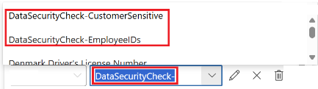

Add additional Sensitive Info Types
The eDiscovery Search can be extended to search for additional Sensitive Info Types as defined by the customer. Repeat the steps below for each Sensitive Info Type that needs to be added.
- On the DataSecurityCheck-CS-Custom-SharePoint page, on the Condition builder tab, click on +Add conditions, and on the dropdown menu select Show more.
- On the Choose which conditions to add fly-out, below Conditions for SharePoint and OneDrive sites, select Sensitive Type.
- Click on Apply.
- On the Connection builder tab, In front of Sensitive Type, set the logical operator to OR and select the Custom Sensitive Information Type that needs to be included in the search, leave the Min, Max, and Confidence input boxes blank.
- Repeat the steps above for every Custom Sensitive Info Type that needs to be additionally added.
Run the Query
- On the DataSecurityCheck-CS-Custom-SharePoint page, click on Run query.
- On the Choose search results flyout, below Statistics, select Include categories and Include query keywords report.
- Click on Run Query.

Note
The search will run after creation. The time it takes to complete the search depends on the amount of data, the complexity of the search query, and the location where the data is stored. Refer to Limits in eDiscovery for details..

Next step
- Return to the <00-Master Delivery Guide> and continue the guidance provided in Step 3 - Setup and configuration.

Step 4 - Analyze the findings
In this step the partner will, together with the customer’s tenant / compliance administrator, analyze all logs, information, and reports generated by the different Data Security Check tools and services. This section describes the additional steps required to prepare and analyze the results from the Automated Discovery for SharePoint Online.
It is recommended to do a two-step analysis of the logfiles, reports, and findings:
- Quick scan. By using the various dashboards and preview views you will be able to identify common patterns and/or trends that need further investigation and can serve as an example of data security risks. Look for “most impactful” events related to important people within the organization, high volumes of documents related to a specific business process, Personally Identifiable Information (PII), etc.
- Detailed analysis. Using exported log and report files for the various services will allow for further investigation of previously identified data security risks and events flagged during the quick scan. Aim at determining the impact and risk and consider possible solutions for mitigation. During this detailed analysis you are advised to leverage the insights of the customer team because they will know what and who to look for. To rule out “false positives” you are advised to do further investigation of all the events that will be included in the final closeout presentation at the end of the engagement.
Important
It is important to stay within the scope of this activity while analyzing the findings and identified data security risks. Unless exceptional risks are identified that require immediate action, the activities for this step should be limited to analysis and not extend to mitigation or corrective action. If corrective action or mitigation is required, this should be discussed with and approved by the customer prior to engaging in these out-of-scope activities. The objective of the Data Security Check is to highlight data security risks to the customer’s organization and to understand, learn, and advise on what can be done to mitigate these risks.

Pre-requisites
Prior to starting the activities in this step, the following mandatory Data Security Check activities as described in <00-Master Delivery Guide> should be completed:
- Step 1 - Kick-off meeting
- Step 2 - Acquire and assign licenses
- Step 3 - Setup and configuration

Prepare for analysis – eDiscovery Search

Guidance
Follow the steps outlined in this section to generate and export reports related to eDiscovery Search.

Objective(s)
- Update the search results to include data that was created over the time the Automated Discovery was active.
- Generate and export the search reports.

Background reading
For more information refer to:
- Evaluate and refine search results in eDiscovery

Instructions
- On the local workstation, if not already done, extend the previously created directory structure by creating the \DataSecurityCheck\SharePointOnline folder.
- Browse to the Microsoft Purview portal at https://purview.microsoft.com/ and log in with Tenant Admin credentials or a user account that is a member of your Data Security Check team and has been assigned the appropriate permissions.
- In the navigation bar on the left side, click on Solutions .
- In the Solutions navigator, click on eDiscovery.
- On the eDiscovery solution card, click on Cases.
- On the Cases page, click on the previously created case DataSecurityCheck-Case.
Update search results
- On the DataSecurityCheck-Case page click on the first search related to SharePoint in the list.
- On the <SearchName> page, on the Statistics tab, inspect the Last run on date.

- If the Last completed date is more than two to three days ago, the search results should be updated by clicking Regenerate view.
- On the Regenerate statistics view flyout, select Include categories and Include query keywords report and click Run query.
- In the search trail, click on Searches to return to the DataSecurityCheck-Case page.
- Repeat the Update search results steps for all other SharePoint related searches that are out of date.

Note
Updating the search results depends on the amount of data in the customer’s tenant and can take significant time to run. If possible, try to schedule re-running the search in advance.

Search statistics
- On the DataSecurityCheck-Case page page, search for DataSecurityCheck- and click the first search related to SharePoint in the list.
- On the <SearchName> page, click on Statistics.
- On the <SearchName> page, on the Search statistics tab, create a screenshot of the Search Summary.
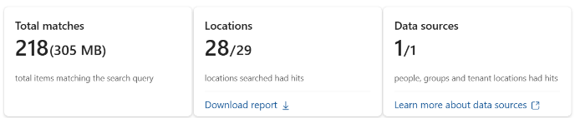

Note
Refer to Use Snipping Tool to capture screenshots for guidance on taking screenshots.

Note
Before saving the screen shot, it is advised to edit the image and add a descriptive header, this will make it easier to recognize the screenshots when inserting them in the <41-Close-out deck>. For example:
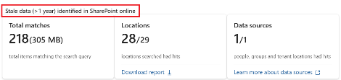.

- Save the screenshot as Summary-<Search Name>.jpg to the \DataSecurityCheck\SharePointOnline folder on your local workstation.
Top 100 locations
- On the <SearchName> page, on the Statistics tab, on the Top data sources card, click View top 100.
- On the Data source page, create a screenshot of the First 10 rows.
- Save the screenshot as Top10-<Search Name>.jpg to the \DataSecurityCheck\SharePointOnline folder on your local workstation.
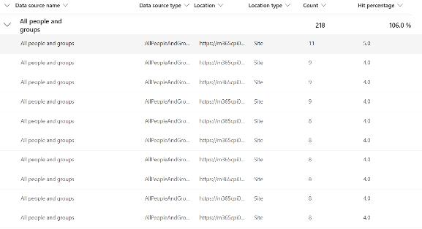
- On the bottom of the Data source page, click on Download report.
- Save the report as Top100-<Search Name>.csv to the \DataSecurityCheck\SharePointOnline folder on your local workstation.

Note
By default, all export files are named <data_sources_report.csv>. Because you will be exporting a file for every search you have created, change the filename to include the name of the search.

- Repeat the Search statistics and Top 100 locations steps for all other SharePoint-related searches.

Analyze results - eDiscovery Search

Guidance
The results for each search are exported to three individual files (see paragraph 2.4.1 Prepare for analysis – eDiscovery Search). The contents of these files should be analyzed, and where applicable, copied to the placeholder slides in the closeout-presentation <41-Close-out deck>.

Filename: Summary-<Search Name>.jpg
Location | \DataSecurityCheck\SharePointOnline
Contains | Summary providing a high-level overview of:  - Total items matching the search query  - Number of locations with content matching the search query.  - Number of data sources with content matching the search query.
Usage | Provides high-level overview of findings.
Use in closeout deck? | YES
Instructions | - Copy the saved screenshot to the appropriate slide(s) in the <41-Close-out deck>.  - Provide relevant information about the search in the slide title.
Sample illustrations | 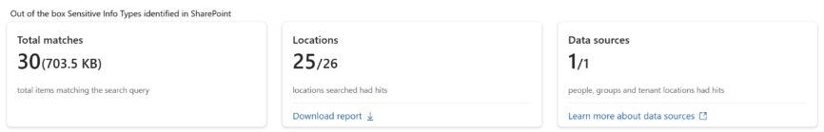  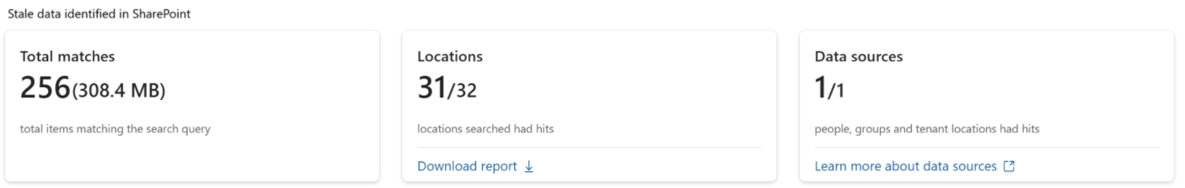

Filename: Top100<Search Name>.csv
Location | \DataSecurityCheck\SharePointOnline
Contains: | Overview of top locations for identified content  - Location  - Location type  - Number of items  - Hit percentage
Usage | Overview of top locations.
Use in closeout deck? | YES
Instructions | - Copy the saved screenshot to the appropriate slide(s) in the <41-Close-out deck>.  - Provide relevant information about the search in the slide title.
Sample illustration | 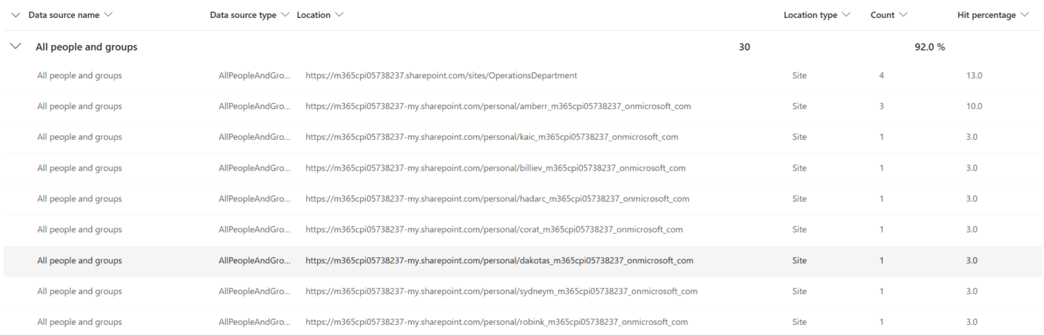  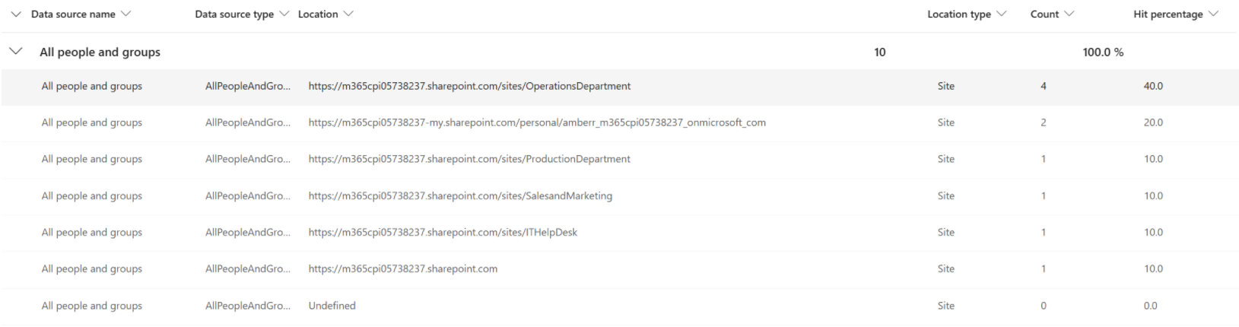

Filename: Top100<Search Name>.csv
Location | \DataSecurityCheck\SharePointOnline\
Contains | Detailed inventory of all search locations and identified risks  - Search location and location type  - Detailed information about every item identified.
Usage | In-depth investigation
Use in closeout deck? | NO
Instructions | - Import the export file into Excel following the instructions in the appendix in the <00-Master Delivery Guide>.  - Analyze and create pivot tables to investigate
Sample illustration | N.A.

Next step
- Return to the <00-Master Delivery Guide> and continue the guidance provided in Step 4 - Analyze the findings.

Step 6 - Decommission

Guidance
The final activity for the Automated Discovery for SharePoint Online activity is to decommission the services and tools used for this activity.

Objective(s)
The objectives for this activity are:
- Decommission the services that were installed to support the Automated Discovery for SharePoint Online.

Deliverable(s)
For this activity, the following deliverables have been defined:
- All tools and services used during the Automated Discovery for SharePoint Online are decommissioned.
- All custom configuration artifacts are removed from the customer’s tenant.

Instructions – Delete eDiscovery Search
Individual eDiscovery Searches cannot be deleted from an eDiscovery case, refer to the instructions in the <00-Master Delivery Guide> to delete the case from the Microsoft Purview eDiscovery.

Next step
- Return to the <00-Master Delivery Guide> and continue the guidance provided in Step 6 - Decommission.

